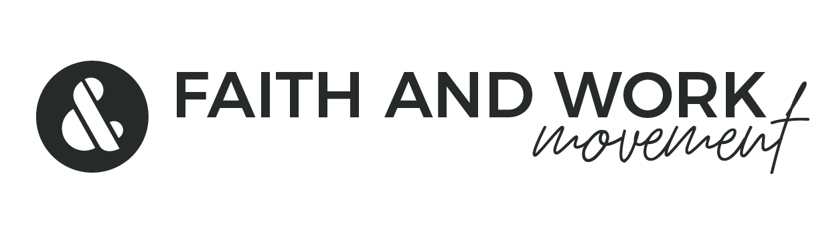
GIVING CRYPTO TO FAITH & WORK MOVEMENT GLOBAL

If you would like to give CRYPTO, we have partnered with The Signatry

Signatry will convert your Cryptocurrency into charitable dollars in a fund. Once that is done, you can designate those dollars to Faith & Work Movement Global like you would a DAF..

Please visit https://thesignatry.com/asset-giving/cryptocurrency/
For more information and a list of cryptocurrency they accept.

Once your Crypto is converted to a fund, to give to F&WM is similar to a Donor Advised Fund.

You can find the information you need to give below:

The official name of our ministry is Faith and Work Movement Global. If making a check donation, please use the following information:

Make check payable to:
Faith and Work Movement Global

Our IRS EIN number is 83-3090941
You can obtain our tax exempt determination letter at:
https://www.irs.gov/charities-non-profits/search-for-tax-exempt-organizations
You can find our organization by searching by our full name or our EIN number.

Mailing address to send checks to:
Faith and Work Movement Global
P.O. Box 1853
Mountain View, CA 94042

Contact Person for Faith and Work Movement : Esther Tinklenberg Email: esther@faithandworkmovement.org

